create database Employee_Database_CS154;

USE EmpLOYEE_DATABASE_CS154;

create table dept(deptno varchar(20),

dname varchar(20),

dloc varchar(20),

primary key(deptno));

create table employee(empno int ,ename varchar(20),

mgr_no int,

hiredate varchar(20),

sal float,

deptno varchar(20),

primary key (empno,deptno),

foreign key (deptno) references dept(deptno));

create table incentives(empno int ,

date varchar(20),

amt float,

primary key (empno,amt),

foreign key (empno) references employee(empno));

create table project (pno int primary key,

ploc varchar(20),

pname varchar(20));

create table Assignedto(empno int ,

pno int,

job_role text,

primary key(empno,pno),

foreign key(empno) references employee(empno),

foreign key(pno) references project(pno));

insert into dept values(1,"cse","pj");

insert into dept values(2,"ise","pj");

insert into dept values(3,"csds","pg");

insert into dept values(4,"ece","pg");

insert into dept values(5,"aiml","pj");

insert into employee values(101,"mdr",100,"12/01/1999",100000,1);

insert into employee values(201,"sak",200,"17/01/2020",50000,2);

insert into employee values(301,"grp",100,"01/09/2004",30000,3);

insert into employee values(401,"sws",101,"03/08/2000",10000,4);

insert into employee values(501,"sks",101,"29/2/2008",90000,5);

insert into incentives values(101,"12/03/2004",50000);

insert into incentives values(201,"17/03/2024",25000);

insert into incentives values(301,"01/12/2019",15000);

insert into incentives values(401,"03/11/2019",5000);

insert into incentives values(501,"29/4/2019",45000);

insert into project values(10,"Bangalore","chatbot");

insert into project values(40,"Delhi","ml model");

insert into project values(50,"Bombay","blockchain");

insert into project values(30,"Chennai","stocks");

insert into project values(80,"Mysore","android app");

insert into Assignedto values(101,10,"devops");

insert into Assignedto values(201,40,"sde");

insert into Assignedto values(301,50,"manager");

insert into Assignedto values(401,30,"jpa");

insert into Assignedto values(501,80,"pa");

select * from dept;

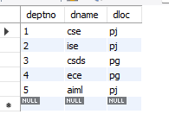

Select * from employee;

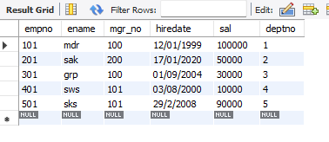

Select * from incentives;

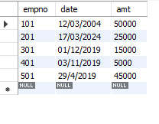

select * from project;

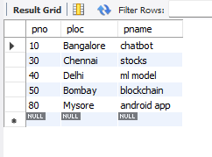

SELECT * FROM Assignedto;

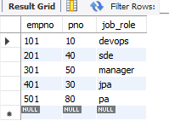

select a.empno from Assignedto a

where a.pno=any(select pno from project

where ploc in ('Bangalore','Hyderabad','Mysore'));

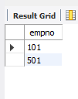

select e.empno from employee e

where e.empno!=all(select i.empno from incentives i);

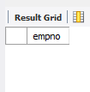

select e.empno,

e.ename,d.dname,a.job_role,d.dloc,

p.ploc from employee e,dept d,Assignedto a,project p

where e.deptno=d.deptno and e.empno=a.empno and

a.pno =p.pno and d.dloc=p.ploc;

